HOWTO -- Documentation

The documentation is simple and straight forward. Just start with the Introduction and follow the install steps.
I. | Introduction
II. | Prerequisites
III. | Configuring a PC to serve as a host for your images
IV. | Downloading and Burning the PING ISO
V. | Installing your own PXE Server to allow network hosts to boot PING
VI. | Using PING
VII. | Storing an image on a Bootable ISO
VIII. | Annex

Introduction
The following installation steps will enable you to backup and restore whole systems through your network, be it professional or domestic.
At the end of the installation, you should be able to boot any computer on your network, then hit the F12 key during the boot process, and launch the PING distribution from the network. Using this tool, you should be able either to backup, either to restore partitions. Think of it as a Ghost-like process. You'll be able as well to record such "ghosted" images on a bootable DVD.

Prerequisites
To use the PING distribution, you need at least the following :
- A LAN (Local Area Network). At least two connected computers. One of these computers is to be backuped or restored, and the other is supposed to store the images you'll do with PING.
- A Share. The computer used to store the images must be able to share files (any Microsoft Windows computer can). If you're a Linux user, install Samba.
- Space. The computer used to store the images should have enough space disk. To store a full 40 Go hard disk, you might need 20 Go.
Nothing more...

Configuring a PC to serve as a host for your images
Directory names are given here as samples. Adapt the following according to your specific needs and configuration.
- Download PartImage.zip and save it on C:\
- Open C:\ and uncompress the archive (choose: extract here)
- You should have a C:\PartImage directory, containing several subfolders (eg.: a Create_New_Image subfolder)
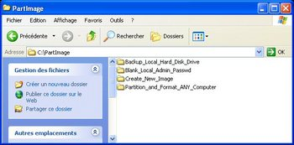

- Right-click on the C:\PartImage folder and share it. Set the permissions as suits you. Just keep in mind that you'll have to be able to write on this shared folder from any host on your network. Create a user if necessary.

Downloading and Burning the PING ISO
- Download PING.1.11.iso

- Burn it using your favorite Burning Software
  - With Nero:
    - Open Nero Burning Rom
    - Select Recorder / Burn Image
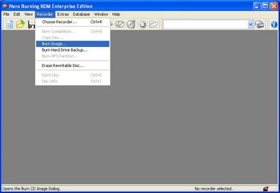

    - Browse to PING.1.10.iso

  - If you have no tool to burn an ISO:
    - Go to Alex Feinman's website and download what IsoRecorder version suits your configuration. It's freeware. Install it.
    - Then, open the folder containing the PING.1.10.iso file, right-click on the ISO, and choose "Copy Image to CD"

Installing your own PXE Server to allow network hosts to boot PING (Optional step)
Directory names are given here as samples. Adapt the following according to your specific needs and configuration.
- If you've got a working RIS Server (like MS Windows Server 2000 or 2003) :
  - You probably have a \\server_name\RemInst\Setup\English\Images\ directory, used to share images for the RIS server.
  - Create the following folders:
    - \\server_name\RemInst\Setup\English\Images\PING\
    - \\server_name\RemInst\Setup\English\Images\PING\i386\
    - \\server_name\RemInst\Setup\English\Images\PING\i386\templates\
    - \\server_name\RemInst\Setup\English\Images\PING\i386\templates\pxelinux.cfg\

  - In the \\server_name\RemInst\...\templates\ directory, download the following files:
    - kernel
    - initrd.gz
    - pxelinux.0

  - In the \\server_name\RemInst\...\templates\ directory, create a text file that you'll name ping.sif, containing:
[OSChooser]
Description = "PING 1.10 (Partimage Is Not Ghost)"
Help = ""
LaunchFile = "Setup\English\Images\PING\i386\templates\pxelinux.0"
ImageType = Flat
Version="1.10"
  - In the \\server_name\RemInst\...\templates\pxelinux.cfg\ directory, create a text file that you'll name default, containing:
DEFAULT rescue
PROMPT 0
LABEL rescue
KERNEL kernel
APPEND vga=normal devfs=nomount pxe ramdisk_size=40000 load_ramdisk=1 init=/linuxrc prompt_ramdisk=0 initrd=initrd.gz root=/dev/ram0 rw noapic lba acpi=off

- If you have no working RIS Server and want to build your own easily :
  - Install TFTPD32 from Ph. Jumin's web site
  - On your future PXE / RIS Server, create the following directories:
    - D:\PXE\
    - D:\PXE\i386\
    - D:\PXE\i386\templates\
    - D:\PXE\i386\templates\pxelinux.cfg\

  - In the D:\PXE\i386\templates\ directory, download the following files:
    - kernel
    - initrd.gz
    - pxelinux.0

  - In the D:\PXE\i386\templates\pxelinux.cfg\ directory, create a text file that you'll name default, containing:
DEFAULT rescue
PROMPT 0
LABEL rescue
KERNEL kernel
APPEND vga=normal devfs=nomount pxe ramdisk_size=40000 load_ramdisk=1 init=/linuxrc prompt_ramdisk=0 initrd=initrd.gz root=/dev/ram0 rw noapic lba acpi=off

  - Launch TFTPD and configure it the following way:

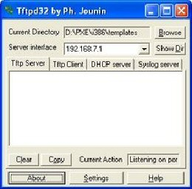 | If you've got several network cards in your computer, you'll have to choose in the server interface area the one that communicates with your other LAN hosts.
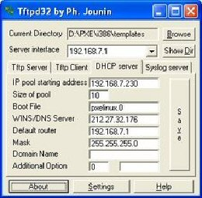 | Configure your DHCP Server here. Booting with PXE is not possible unless you define it. A common network configuration is to have addresses like 192.168.0.x with 192.168.0.1 as the router (often a workstation connected both to the internet, both to the LAN, and sharing the internet connection on the LAN).
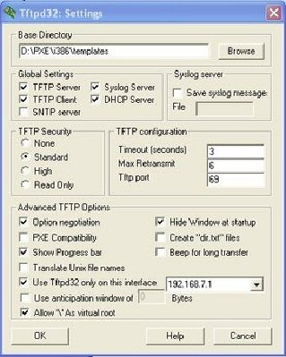 | Nothing special here.

  - That's all ! Test your PXE Server: go to a LAN workstation, reboot it, and press F12 to boot on the network. Note: if you don't see the F12 prompt, you might have to modify the BIOS setup and enable PXE.
In the following section, we'll be booting from a CD, made by burning the PING ISO. But this should give exactly the same result.

Using PING
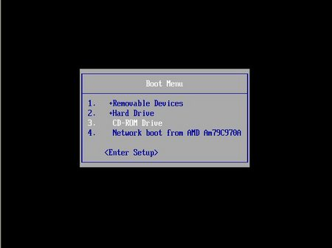 | Choose to boot on the CD you've burnt with the PING ISO.  If you don't see the option in your boot sequence, you'll probably have to modify your BIOS settings.  Note that a PXE Server is needed to boot from the network.
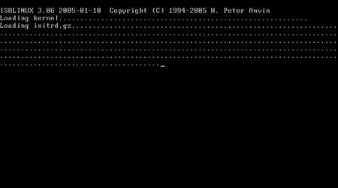 | Our Linux kernel has been loaded, and our distribution is being uncompressed.
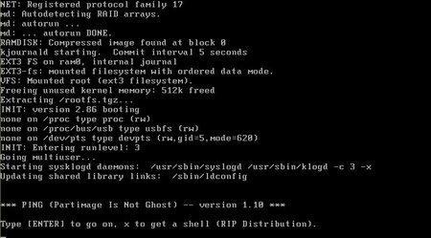 | Press ENTER to go on.  Note that if you don't want to use our menu-driven wizard, you might press x and ENTER to get a shell. User root has no password.
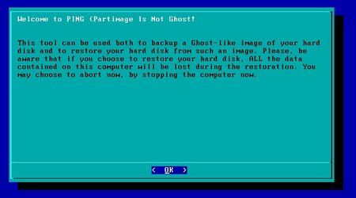 | Usual warnings. Press ENTER.  The wizard will then try to connect to the LAN. If it doesn't succeed in getting an IP from a DHCP server, it will ask you for an IP, a netmask, and a gateway IP.
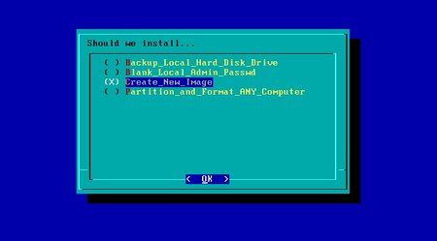 | Here, you'll find the list of available images. They are stored in the PartImage directory of your host computer. Choosing one image will restore the computer with it, thus erasing all your hard disk.
But by default, as shown in the screenshot, there are only these 4 special images. They act as commands.
- Backup Local Hard Disk: will zip your drives on a network share
- Blank Local Admin's password: will change administrator's password to an empty string
- Create New Image: to save a Ghost-like image of your hard disk, BIOS settings included (we choose it)
- Partition and Format ANY Computer: this image will partition computers according to settings present in your \PartImage\ Partition_and_ Format_ANY_Computer\ hda.part file. Edit it to suit your needs.
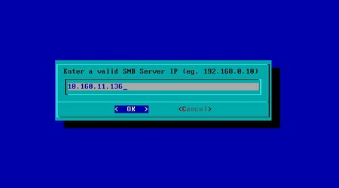 | We need to know where to save the image.  Give the IP of the computer you've shared the PartImage folder on.
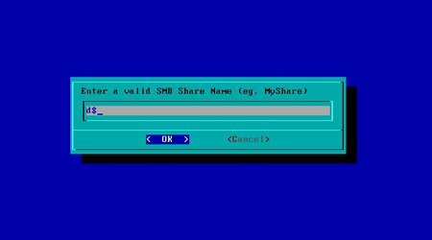 | Now, the name of the share.  Example: \\mydomain\temp => the share is called temp.
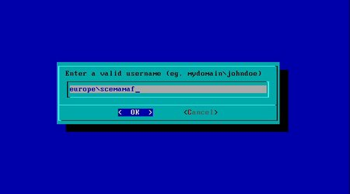 | Now, the user name on the network.  It might also be a local account (eg.: administrator).  (You'll be asked for the password afterwards.)
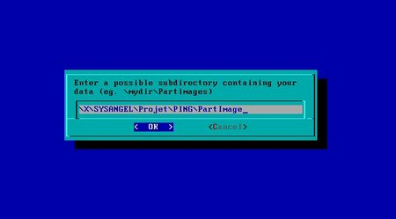 | Now, the directory path, from the share to the PartImage directory.  Example: if you created C:\PartImage on server Billy, and shared it, then your resource should be \\billy\partimage. So, IP is Billy's IP, share is partimage, and directory is nothing.  Example: if you created C:\temp\PartImage on server Billy, but shared the temp directory, then your resource should be \\billy\temp\partimage. So, IP is Billy's IP, share is temp, and the directory is \partimage.
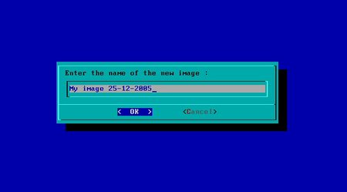 | Finally, tell the wizard how will be called your new image.  On your storage computer, we'll create a new \PartImage\NameOfImage directory.
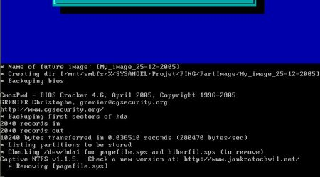 | That's all.  In this screenshot, BIOS settings are being saved...
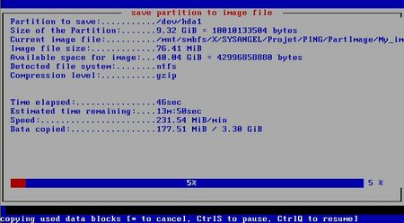 | Then, the partitions themselves...

Storing an image on a Bootable ISO
Storing an image on a LAN computer is nice, but sometimes, you may want to burn this image on a bootable DVD. It can be useful to bring such a media to a remote site, and regenerate a computer. It can also be considered as a practical way to backup a whole system.
Directory names are given here as samples. Adapt the following according to your specific needs and configuration.
- We suppose you've recorder an image within the C:\PartImage\ directory. The image is called My_Image_2005-12-25.
- Download initrd.gz and save this file within the C:\PartImage\My_Image_2005-12-25\ directory.
- Download kernel and save this file within the C:\PartImage\My_Image_2005-12-25\ directory.
- Download isolinux.bin and save this file within the C:\PartImage\My_Image_2005-12-25\ directory.
- Create a text file, called isolinux.cfg, within the C:\PartImage\My_Image_2005-12-25\ directory, containing:
DEFAULT rescue
PROMPT 0
LABEL rescue
KERNEL kernel
APPEND vga=normal devfs=nomount pxe ramdisk_size=40000 load_ramdisk=1 init=/linuxrc prompt_ramdisk=0 initrd=initrd.gz root=/dev/ram0 rw noapic lba
- Download CDR Tools 2.0.1. Install the EXE (there’s an embedded MSI) on your computer.
- Open a DOS Prompt and go to your image directory:
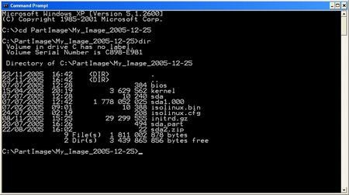
- Use mkisofs (from CDR Tools) to generate a bootable ISO:
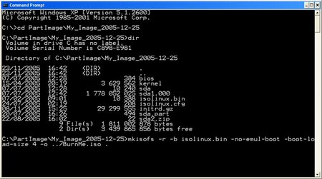
mkisofs -r -b isolinux.bin -boot-info-table -no-emul-boot -boot-load-size 4 -o ../BurnMe.iso .
(don’t forget the trailing dot).
- The ISO generation should start...:
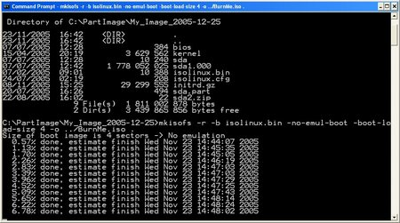
- And you should get a full working C:\PartImage\BurnMe.iso image.
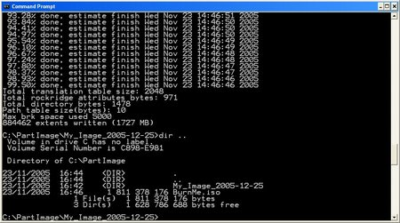
- Burn the ISO. That's all.
Note: You might use Ahead Nero or any third-party software to generate a bootable ISO. Your mileage might vary.

Annex
Notes :
- To suggest a new feature, please visit the Forum.
- After reinstalling a whole system, you might want to have it updated.
Use our Software Updater: it will download and install brand new software from our internet repository.
- TIP: if you've got to duplicate an image over several computers within a LAN, you'll have to regenerate Windows' SID. To do so, use newssid.exe from SysInternals.
- You can edit the C:\PartImage\My-Image\hda.part file. You'll see some help inside the file.

